CHAPTER 3: Cells
Worksheet 3.3

Preparing a stained wet mount
Answers
Jumbled steps
1. The following diagrams show the jumbled steps used to prepare a wet mount of onion epidermis. Place the code letters in the correct sequence.
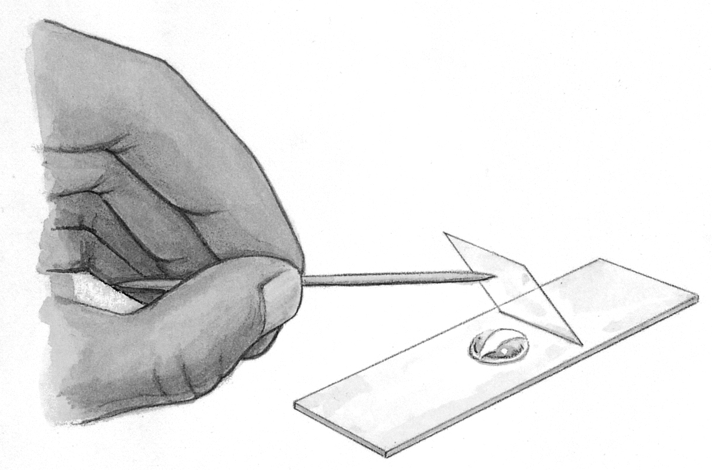 | 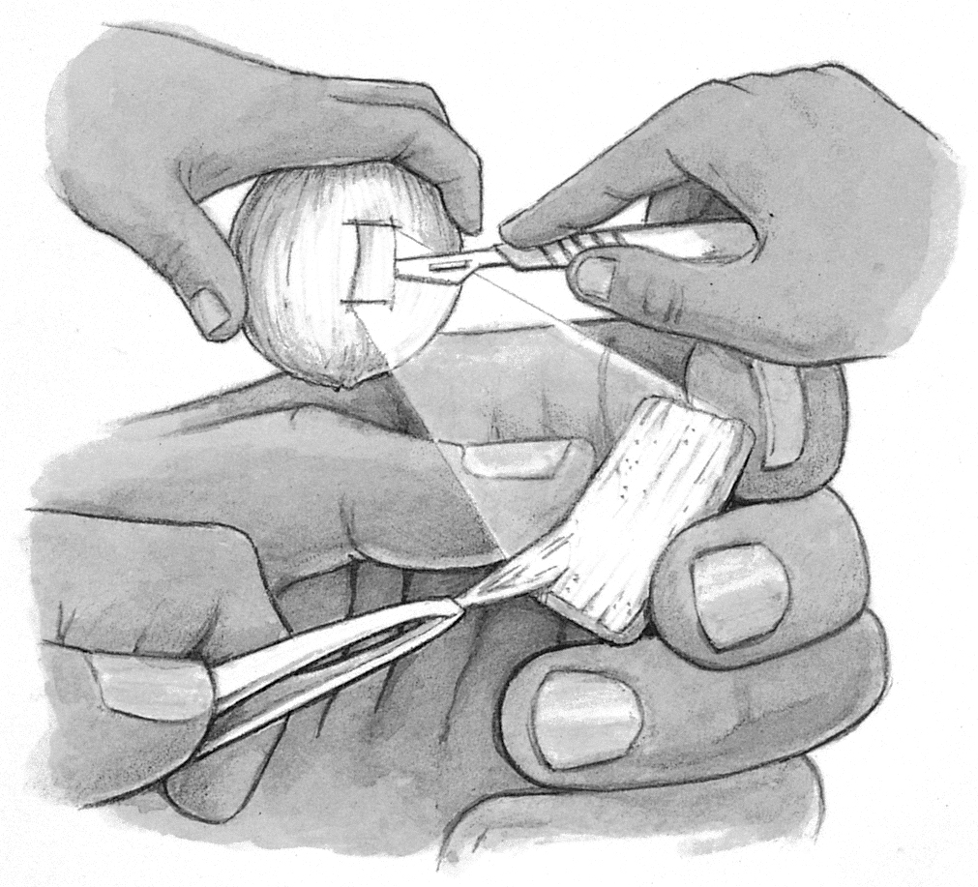 | 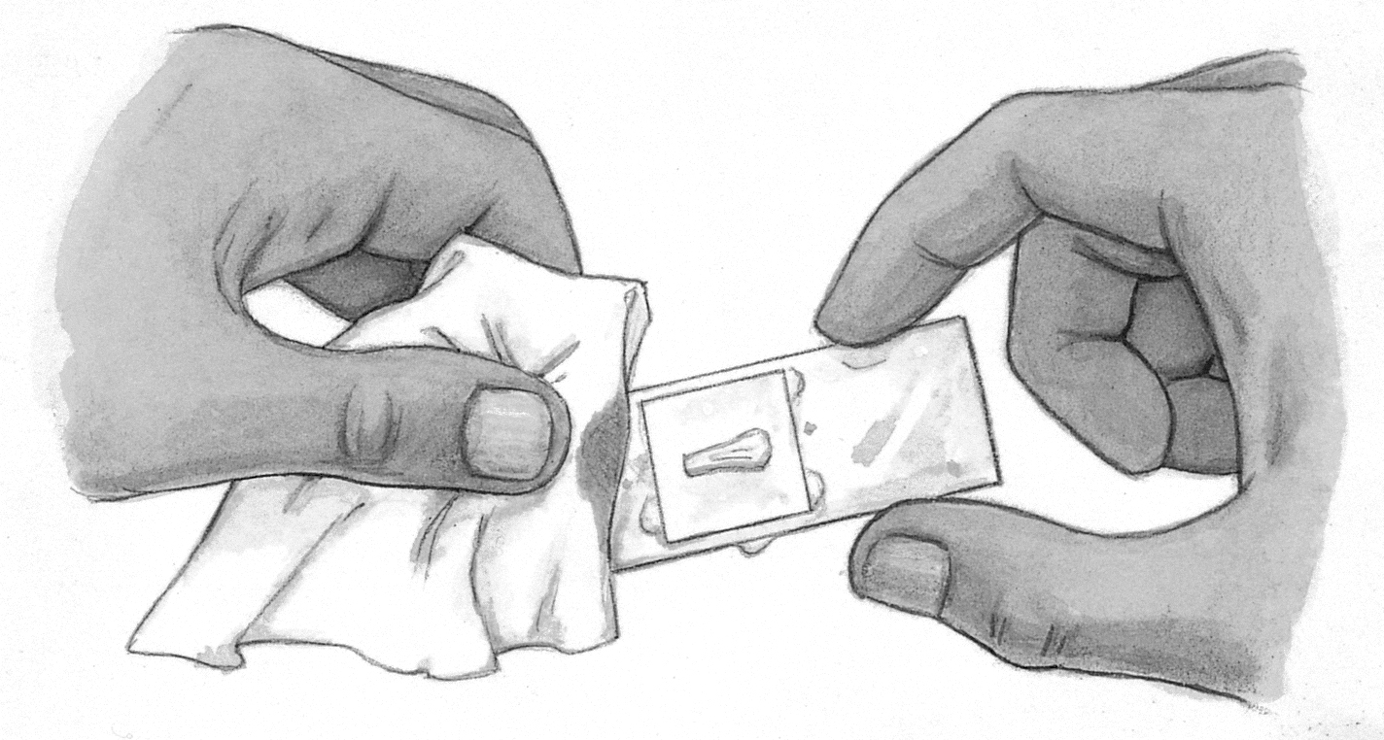 | 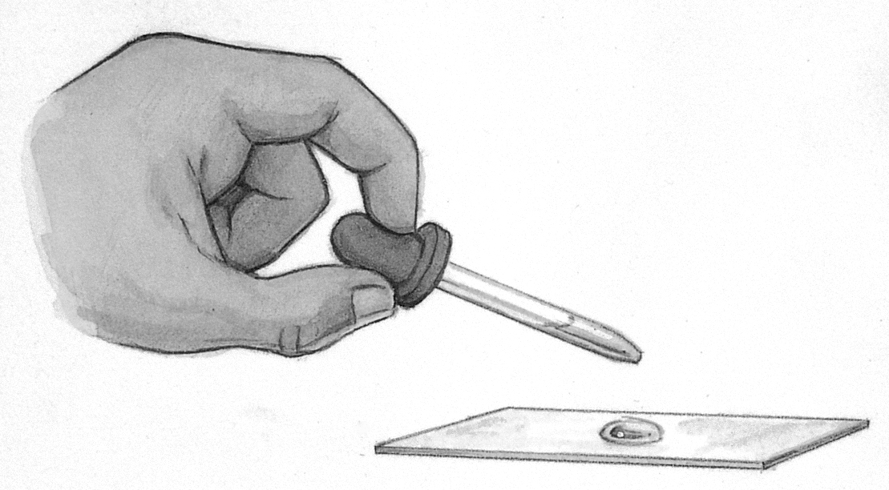 | 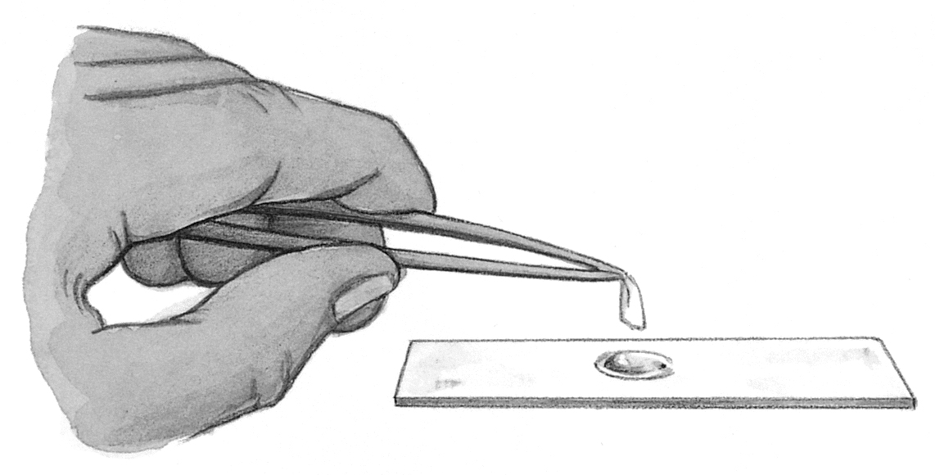
A. Lower a coverslip over the onion skin and water droplet. | B. Peel a section of onion epidermis.  B, D, E, A, C | C. Soak up excess water with a tissue. | D. Add a drop of water to a microscope slide. | E. Place onion skin in drop of water on the slide.
Correct sequence:
Staining cells
2. It is much easier to see the internal structure of cells by staining the tissue. The following materials are available to prepare a stained wet mount of onion epidermis.
dropping bottle of methylene blue or other similar stain, microscope, microscope slide,
coverslip, small section of a peeled onion, forceps, toothpick, dropping bottle of water
(a) Write a method for your investigation.
1. Peel a section of onion epidermis and remove a section of epidermis with forceps.
2. Add a drop of methylene blue to a slide.
3. Place the onion epidermis in the stain.
4. Cover with a coverslip using a toothpick to lower the coverslip.
5. Remove excess stain with a tissue.

(b) The drawing below left was made of the stained onion epidermal tissue.
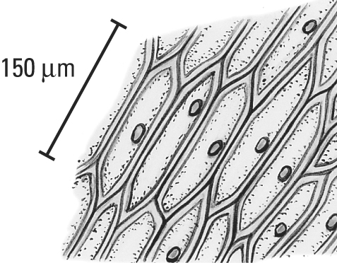 | (i) The nucleus and cell walls take up the methylene blue stain. Use a blue pencil to colour these components in the drawing.  (ii) Use the scale to estimate the greatest width of a cell. | (iii) The experiment was repeated with iodine stain, which strongly stains starch grains a deep blue-black colour. Use coloured pencils to colour the starch grains, which are scattered in the cytoplasm in the cells at the right. | 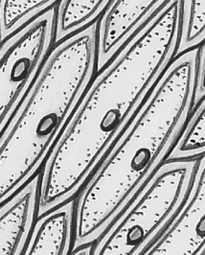
(i) Students colour the cell walls and nuclei blue. (ii) 35–40 μm
(iii) Many tiny starch grains should be coloured blue-black.

